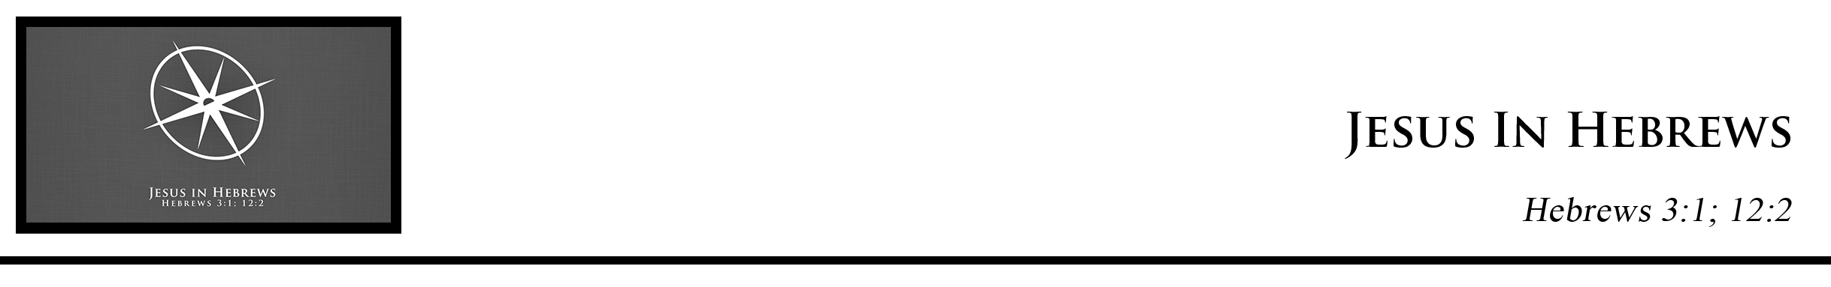Description: confused 02

***Hebrews 3:1*** *Therefore, holy brothers,you who share in a heavenly calling, consider Jesus, the apostle and high priest of our confession*

***Hebrews 12:2***

*looking to Jesus, the founder and perfecter of our faith, who for the joy that was set before him endured the cross, despising the shame, and is seated at the right hand of the throne of God.* (ESV)

Dr. William Varner • Compass Bible Church • October 8 & 9, 2016 • Msg. G16-12

**1. Fix Your Thoughts on the ____________________________ of Our Faith**

**2. Fix Your Eyes on the ________________________________ of Our Faith**

**Application Questions**

*These questions are provided for your further study and application of today’s sermon. Thoughtfully writing out the answers to these questions will help to drive home the point of today’s study. It is also helpful when you are able to discuss your answers with others. For more information about small groups at Compass Bible Church that utilize these questions as the basis for their weekly discussion, please call the church office at (949) 540-0699 or email us at SmallGroups@CompassChurch.org.*

1. Read **Hebrews 1**. What two types of “apostles” (sent ones) are mentioned in this chapter? How do these differ in their purpose and why are you grateful for their differing ministry to you?

2. Read **Hebrews 4:16**.  Based on this verse, what two blessings does our High Priest give us? What are the differences between the two important blessings, and in what ways have your experienced their impact on your life?

3. Read **Hebrews 12:2**. What was the race that Jesus endured for us? How should pondering this race enrich the way you worship Christ? What costly aspects of his race do you need to consider more often?

4. Read **Hebrews 12:2-3**. What can Jesus give us because he finished the race? (hint: “e”-word) What are some key areas of your life where this is needed? How can being mindful of this race change the way you approach the challenges you face right now in your life?

*This Week’s*

*Bible Reading Schedule*

**October 9th**

*Is.41-42 & Col.1*

**October 10th**

*Is.43-44 & Col.2*

**October 11th**

*Is.45-47 & Col.3*

**October 12th**

*Is.48-49 & Col.4*

**October 13th**

*Is.50-52 & 1Th.1*

**October 14th**

*Is.53-55 & 1Th.2*

**October 15th**

*Is.56-58 & 1Th.3*

**October 16th**

*Is.59-61 & 1Th.4*